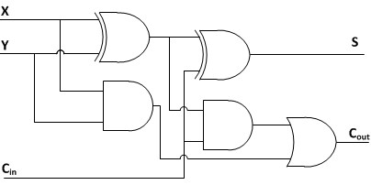

**module** fulladder(**X**, **Y**, Ci, **S**, Co);

**input** **X**, **Y**, Ci;

**output** **S**, Co;

**wire** w1,w2,w3;

//Structural code for one bit full adder

**xor** **G1**(w1, **X**, **Y**);

**xor** **G2**(**S**, w1, Ci);

**and** **G3**(w2, w1, Ci);

**and** **G4**(w3, **X**, **Y**);

**or** **G5**(Co, w2, w3);

**endmodule**

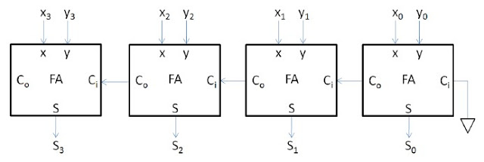

**module** rippe_adder(**X**, **Y**, **S**, Co);

**input** [**3**:**0**] **X**, **Y**;// Two 4-bit inputs

**output** [**3**:**0**] **S**;

**output** Co;

**wire** w1, w2, w3;

// Instantiating 4 1-bit full adders

fulladder u1(**X**[**0**], **Y**[**0**], **1'b0**, **S**[**0**], w1);

fulladder u2(**X**[**1**], **Y**[**1**], w1, **S**[**1**], w2);

fulladder u3(**X**[**2**], **Y**[**2**], w2, **S**[**2**], w3);

fulladder u4(**X**[**3**], **Y**[**3**], w3, **S**[**3**], Co);

**endmodule**